3. Post Charges

Table of Contents
Regular Billing 3
Calculate 4
Interest 6
Post Charges 7
Penalty 9
Percent of Open Balance 9
Flat Amount 11
Post Charges 12
Misc. Charges 13

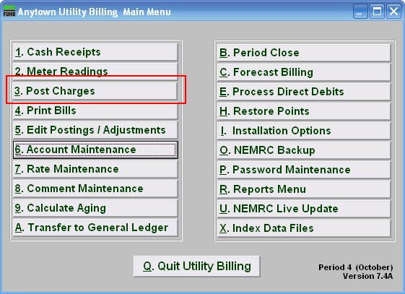
On the Main Menu, click “3. Post Charges.” The following window will appear:
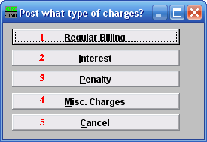
- Regular Billing: Click this button if you want to calculate a regular billing charge for an individual, a book, or all books.

- Interest: Click this button if you want to apply an interest charge to an individual, a book, or all books.

- Penalty: Click this button if you want to apply a penalty charge to an individual, a book, or all books.

- Misc. Charges: Click this button if you want to apply a charge that is neither regular, interest, or penalty.

- Cancel: Click this button to cancel, and return to the Main Menu.

Refer to the section below that relates to your choice.

Regular Billing
If you chose “Regular Billing,” the following window appears:

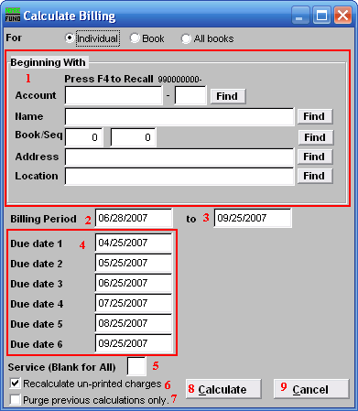
- Beginning With: If you choose “Individual,” choose the account you want to begin calculating with. For additional help on finding accounts, refer to UB GENERAL ACCOUNT LOOKUPS. If you choose “Book,” choose the Book you wish to Calculate billing for. If you choose “All Books,” this section will not be available.

- Billing Period: Enter the beginning date of the billing period. This is the starting date for the period you wish to calculate.

- Enter the ending date of the billing period you wish to calculate.

- Due date 1…6: Enter the due dates to be used in the calculation. The number of due dates offered is dependent on the number of stubs determined in “I. Installation” in the “Book” tab from the Main Menu.

- Service (Blank for All): The service to calculate the billing by, leave blank to use all services. Services are defined in “I. Installation” from the Main Menu.

- Recalculate un-printed charges: Check to recalculate all charges for bills that have not yet been printed.

- Purge previous calculations only: Check to delete all prior calculations for bills that have not been printed.

- Calculate: Click “Calculate” to calculate the charges for this individual account. Refer to the section “Calculate” for further information.

- Cancel: Click “Cancel” to return to the Main Menu without calculating charges.

Calculate
What Calculating does: Using the rates defined in “7. Rates Maintenance,” and attached to a given customer, the system will record or write transactions that generate new billing amounts. This creates a Bill record.

If accounts within the selection you desire indicate that any Meters need to be rolled, the following will appear:

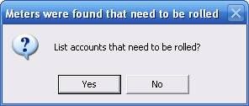
If you choose “Yes” you will be brought to the Preview screen, where you may also choose to print from (refer to GENERAL PREVIEW for more information on this screen). If you choose “No” then you will be returned to the previous screen.

After you choose to calculate, the following window will appear:

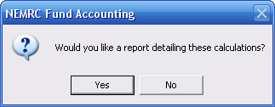
Choose “Yes” and the following window will appear:

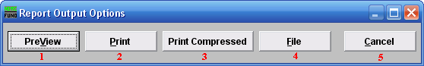
- PreView: Click this button to view a preview report of what was calculated. You may also print from the preview screen. For more information on previewing, refer to GENERAL PREVIEW.

- Print: Click this button to print a report of what was calculated. You may also print from the preview screen. For more information on printing, refer to GENERAL PRINT.

- Print Compressed: Click this button to print a report of what was calculated. This is different from the “Print” option in that it will use less paper for the same report.

- File: Click this button to save a report of what was calculated to this workstation. For more information on saving reports, refer to GENERAL FILE.

- Cancel: Click this button, and click cancel on the windows that appear until asked to reprint, then click “No”. You will return to the regular Billing screen.

Interest
Interest will be applied to the open balance, based on a rate that you determine.

Click “3. Post Charges” from the Main Menu. Click “Interest” from the menu that appears. The following window will appear:

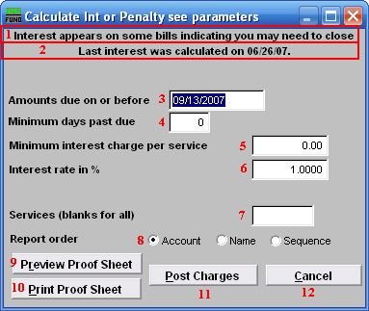

- Message: First line: An indication that there are Active Bill records that have already had interest calculated on them. Typically this means that the period needs to be closed. The “Period Close” function clears interest calculation flags. If you calculate variable interest, than this message should appear for your second round of highest interest. If you use variable interest, contact NEMRC support for more information.

  - Message: Second line: The last time ANY interest was calculated.

- Amounts Due on or before: Enter the due date prior to which interest will be calculated.

- Minimum days past due: Enter the number of days past the due date that the account will begin to be subject to interest.

- Minimum Interest Charge per service: Enter the minimum amount of interest to be charged for each service, as applicable.

- Interest Rate in %: Enter the interest rate as a percentage. (example: “1.0000” meaning 1%).

- Services (Blank for All): Enter the services for which interest should be calculated.. Leave blank to apply to all services. Services are defined in “I. Installation” from the Main Menu.

- Report Order: Click on the circle next to the order in which you wish the report to print.

- Preview Proof Sheet: Click to preview the report prior to printing.

- Print Proof Sheet: Click to print the report.

- Post Charges: Click to post charges to customer accounts and update balances.

- Cancel: Click “Cancel” to return to the Main Menu.

Post Charges
After you chose to calculate, the following window will appear:

Choose “Yes” and the following window will appear:

- PreView: Click this button to view a preview report of what charges were posted. You may also print from the preview screen. For more information on previewing, refer to GENERAL PREVIEW.

- Print: Click this button to print a report of what charges were posted. You may also print from the preview screen. For more information on printing, refer to GENERAL PRINT.

- Print Compressed: Click this button to print a report of what charges were posted. This is different from the “Print” option in that it will use less paper for the same report.

- File: Click this button to save a report (of what charges were posted) to this workstation. For more information on saving reports, refer to GENERAL FILE.

- Cancel: Click this button, and click cancel on the windows that appear until asked to reprint, then click “No”. You will return to the Main Menu.

Penalty

Percent of Open Balance
Click “3. Post Charges” from the Main Menu. Click “Penalty” from the menu that appears. The following window will appear:

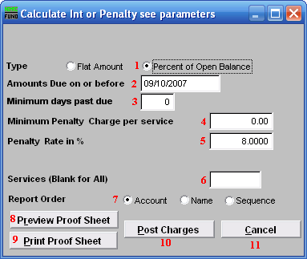
- Click the circle next to “Percent of Open Balance” and the rest of the window will change to what you see above.

- Amounts Due on or before: The due date for bills to be considered for calculation.

- Minimum days past due: Must be a minimum of days beyond the due date, effectively backs up the due date test.

- Minimum Penalty Charge per service: The minimum interest charge that may be applied to each service.

- Penalty Rate in %: The interest rate in percent. (example: 8.0000).

- Services (Blank for All): The services that this penalty should be applied to. Leave blank to apply to all services. Services are defined in “I. Installation” from the Main Menu.

- Report Order: The order that you want the Report to print the accounts.

- Preview Proof Sheet: Preview a proof sheet for this report, used to double-check.

- Print Proof Sheet: Print the proof sheet.

- Post Charges: Post these charges and update the customer balance.

- Cancel: Click “Cancel” to return to the Main Menu.

Flat Amount
Click “3. Post Charges” from the Main Menu. Click “Penalty” from the menu that appears. The following window will appear:

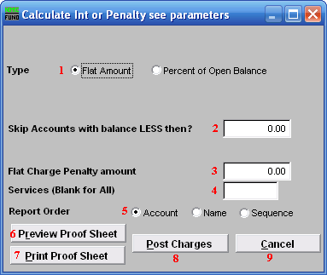
- Click the circle next to “Flat Amount” and the rest of the window will change to what you see above.

- Skip Accounts with balance LESS then?: Accounts with a balance that is less then the amount entered will not receive this charge.

- Flat Charge Penalty amount: The amount that will be charged for this penalty.

- Services (Blank for All): The services that this penalty should be applied to. Leave blank to apply to all services. Services are defined in “I. Installation” from the Main Menu.

- Report Order: The order that you want the Report to print the accounts.

- Preview Proof Sheet: Preview a proof sheet for this report, used to double-check.

- Print Proof Sheet: Print the proof sheet.

- Post Charges: Post these charges and update the customer balance.

- Cancel: Click “Cancel” to return to the Main Menu.

Post Charges
After you chose to calculate, the following window will appear:

Choose “Yes” and the following window will appear:

- PreView: Click this button to view a preview report of what charges were posted. You may also print from the preview screen. For more information on previewing, refer to GENERAL PREVIEW.

- Print: Click this button to print a report of what charges were posted. You may also print from the preview screen. For more information on printing, refer to GENERAL PRINT.

- Print Compressed: Click this button to print a report of what charges were posted. This is different from the “Print” option in that it will use less paper for the same report.

- File: Click this button to save a report (of what charges were posted) to this workstation. For more information on saving reports, refer to GENERAL FILE.

- Cancel: Click this button, and click cancel on the windows that appear until asked to reprint, then click “No”. You will return to the Main Menu.

Misc. Charges
Click “3. Post Charges” from the Main Menu. Click “Misc.Charges” from the menu that appears. The following window will appear:

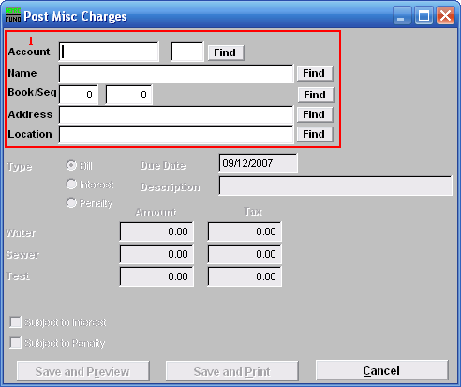
- Choose the account you want to post miscellaneous charges to. For additional help on finding accounts with this screen, refer to UB GENERAL ACCOUNT LOOKUPS.

Once you’ve chosen an account, the following window will appear:

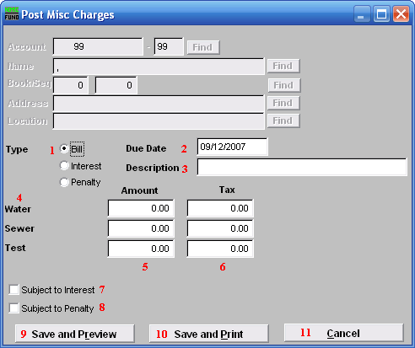
- Type: Click the circle next to the type of charge you are posting.

- Due Date: Click the field to change the date that this charge is due.

- Description: Click the field and type in a short description of this charge.

- Service: The various services, up to four (4), are defined in “I. Installation” from the Main Menu. The services will automatically appear here.

- Amount: The amount being charged.

- Tax: This is only available if you have selected “Bill” as the type of charge. This is the amount of sales tax that is charged with this posting.

- Subject to Interest: This is only available if you have selected “Bill” as the type of charge. Click the box next to this to make this charge subject to interest. Interest charges will be opened to calculation on this posting if it remains unpaid at the next period close.

- Subject to Penalty: This is only available if you have selected “Bill” as the type of charge. Click the box next to this to make this charge subject to penalty.

- Save and Preview: Click this button to save this charge, and view a proof sheet. You may also print from the preview screen. For further information on report previews, refer to GENERAL PREVIEW.

- Save and Print: Click this button to save this charge, and print a proof sheet. You may also print from the preview screen. For further information on printing, refer to GENERAL PRINT.

- Cancel: Click “Cancel” to return to the Main Menu without posting this charge.

